Programming Fundamentals Lab

Lab Assignment 11

Course Code: CL1002

Syed Muhammad Shuja Ur Rahman

Roll No. 22K-4456

Ms. Ayesha Ali

**Question 1:**

Write a program to find out the greatest and the smallest among three numbers using pointers.

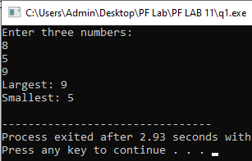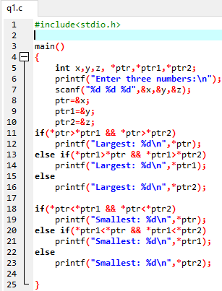

**Question: 2**

Write a C program to swap corresponding elements of two arrays using pointers.

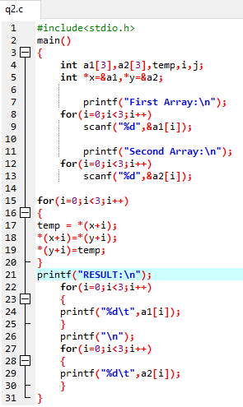

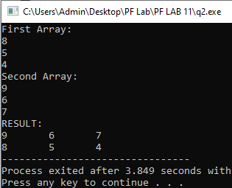

**Question: 3**

Write a program that implements the function(WordCount). int WordCount(char *Text, int *size);

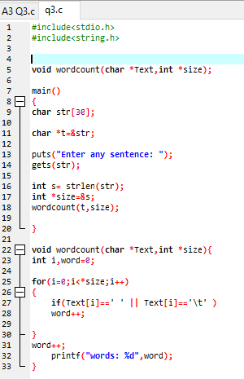

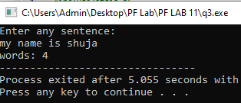

**Question: 4**

Write a C program to add two matrices using pointers. Create a function called calMat() that take pointers of 2 matrices as arguments and return the resulted sum and display it in main.

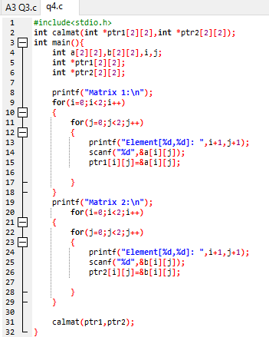

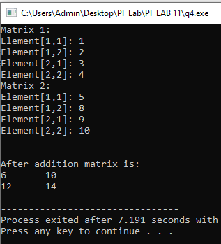

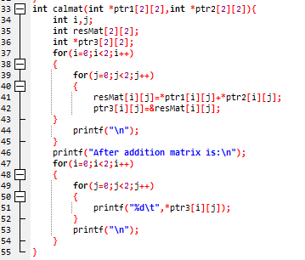

**Question: 5**

Write a function countEven(int*, int) which receives an integer array and its size, and returns the number of even numbers in the array.

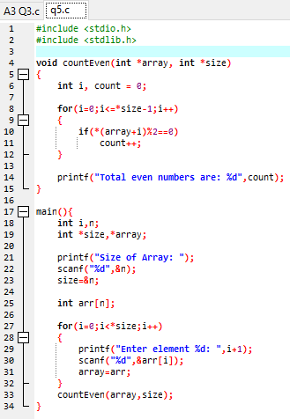

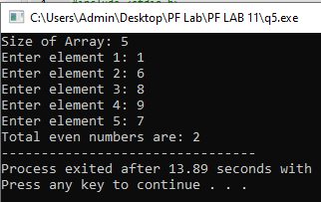

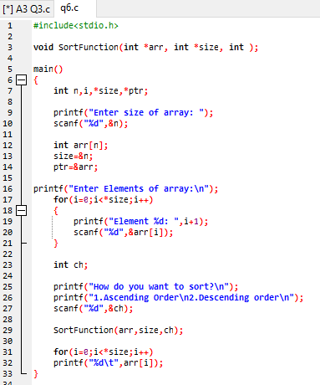**Question: 6**

